The United States and the Global Economy

Section 3 - What Goods and Services Do Countries Trade?

In 2005, Sara Bongiorni and her family carried out an unusual experiment. They tried to live the entire year without buying any products made in China. Bongiorni chronicled the experience in her book, A Year Without “Made in China”:One Family’s True Life Adventure in the Global Economy. The author discovered that Chinese goods are everywhere in the American marketplace. Even American flags are made in China. She came away from that year with a deeper understanding of U.S. ties to the global economy.
The United States not only imports products from abroad. It also exports goods and services to other countries. Imports are products made in another country and sold domestically. Exports are products made domestically and sold in another country. In the global trading system, one country’s exports become another country’s imports, and vice versa.

The United States as a Major Importer
As Sara Bongiorni found out in her year without China, the United States is the world’s leading importer of goods and services. In 2007, its share of world imports was almost equal to that of the next two largest importers, Germany and China, combined.
The first graph in Figure 15.3A shows the kinds of goods and services the United States imported in 2007 by category. The largest category that year was industrial supplies and fuels. This category includes chemicals, minerals, wood products, cotton, petroleum products, and other fuels. Within this category, far more money was spent on imported crude oil than on any other good.
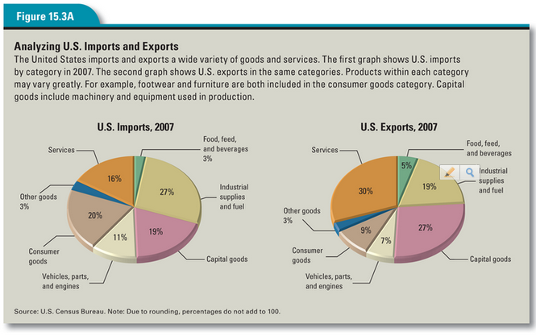

The third largest category of imports in 2007 was capital goods. Included in this group are goods that are used in the production of other goods and services. Examples include machines, computers, measuring instruments, and telecommunications equipment.

The United States as a Major Exporter
The United States is also one of the world’s top three exporting countries, along with Germany and China. Its exports range from farm products, minerals, and manufactured goods to financial and transportation services. The second graph in Figure 15.3A shows the kinds of products U.S. producers export by category.
Capital goods make up the bulk of U.S. exports. Among the most valuable exports in this category are semiconductors, civilian aircraft, industrial machinery, and telecommunications equipment. The United States has a comparative advantage in such high-tech goods because of its high levels of human capital.

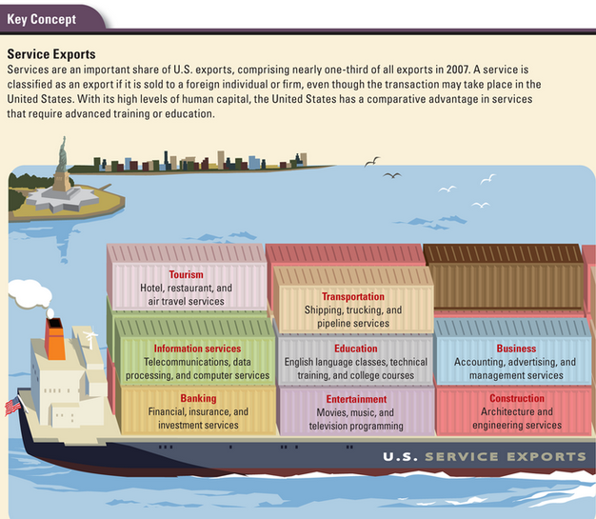
At first glance, it might seem odd that the United States both imports and exports the same types of goods, such as automobiles and telecommunications equipment. The explanation for this paradox lies in product differentiation. German cars and American cars, though similar, are not the same. There is a market for German cars in the United States and a market for American cars in other countries.
In the case of telecommunications equipment, the products differ more substantially. The United States imports cell phones and exports satellite communications equipment. The United States does not have a comparative advantage in cell phone production, but it does have an advantage in satellite technology. Therefore, it makes sense for the United States to export satellite devices and import cell phones.

The Growth of Service Exports
Services also make up a significant share of U.S. exports. In 2007, services accounted for almost one-third of all exports. The illustration below shows the kinds of services the United States exports by category. As with manufactured goods, service exports reflect the country’s comparative advantage in fields requiring a highly trained workforce. Such fields include engineering, education, and information services.
You might be wondering how a service, which is not a physical object, can be exported. Every time an American company sells a service to a foreign customer, whether in the United States or abroad, it is exporting that service. For example, when a foreign student pays to attend college in the United States, that education is considered a service export. Likewise, when a foreign traveler pays for a hotel stay in a U.S. city, that payment is classified as a service export. American banks, airlines, insurance companies, and shipping agencies all add to U.S. export totals when they do business with foreign clients. So, too, do entertainment companies when they sell American movies or musical recordings to customers overseas.

America’s Trading Partners
The United States trades with most countries in the world. However, it conducts more than half of its foreign trade with just ten countries. Figure 15.3B shows America’s top ten trading partners in 2007.
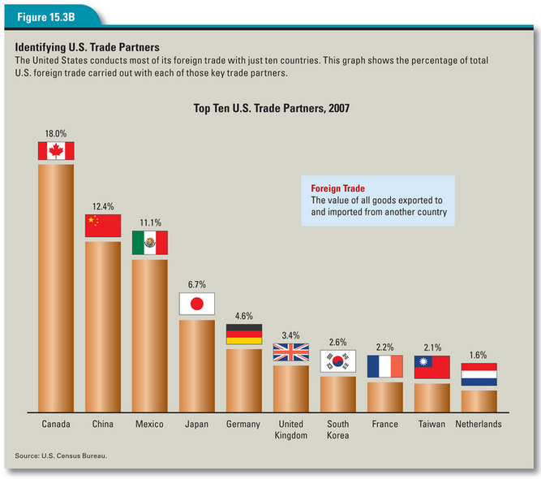
Canada has long been America’s chief trading partner. The long border between the United States and Canada and the traditionally good relations between the two countries have contributed to the growth of U.S.-Canadian trade. In 2007, Canada accounted for 18 percent of all U.S. foreign trade.

After the signing of the North American Free Trade Agreement (NAFTA) in 1994, Mexico became this country’s second most important partner in trade. From time to time, however, growing trade with China has pushed Mexico into third place.
Around half of U.S. trade is with wealthy, industrialized countries such as Germany and Japan. The other half is with newly industrialized countries such as China and oil-exporting countries like Venezuela and Saudi Arabia.

The Benefits of Global Trade for U.S. Consumers
Trade with other countries has many benefits for U.S. consumers. Global trade gives us access to an enormous variety of goods and services. We also enjoy low prices for many goods because we import these goods from low-cost producers. This makes us better off. As economics writer Charles Wheelan points out, “Cheaper goods have the same impact on our lives as higher incomes. We can afford to buy more.” As a result, our standard of living improves.
Global trade also increases competition among producers. This may cause some producers to go out of business, as it did the T-shirt makers of Florence, Alabama. At the same time, it creates new opportunities for innovative or low-cost producers to enter the marketplace. Moreover, the producers that survive become more efficient and productive, thus contributing to a healthier economy. For example, competition from Japanese and European automakers gives U.S. carmakers a strong incentive to make better vehicles at a lower cost. The resulting improvements benefit anyone who buys an American car, whether in this country or abroad.
Finally, global trade enhances the flow of ideas around the world. The movement of products and services among countries opens societies to new ways of doing things. This exchange of new ideas and technologies promotes further innovation.

The Impact of Global Trade on U.S. Workers
As the story of the Florence, Alabama, T-shirt boom and bust makes clear, global trade can also have negative effects on American workers, at least in the short term. Workers who are employed in industries that fail in the face of foreign competition may lose their livelihoods as a result of global trade. In most cases, laid-off workers find new jobs. But some never manage to recover their former standard of living. This results in real hardship for people and communities.
While some workers may have suffered as a result of global competition, the labor force as a whole has not. In 1971, when Mark McCreary opened his Florence T-shirt factory, the U.S. labor force participation rate was 60 percent. By 2003, the year his factory closed because of cheap imports, the percentage of adults in the labor force had risen to 66 percent.
In the long run, global trade increases economic activity. This, in turn, promotes economic growth. Workers who lose their jobs but retrain themselves for new careers generally improve their circumstances. As in any market, competition among buyers and sellers produces winners and losers. But for countries that use their resources wisely and exploit their comparative advantages, the gains created by global trade outweigh the losses.

